WEBSITE:
https://www-k6.thinkcentral.com/ePC/start.do

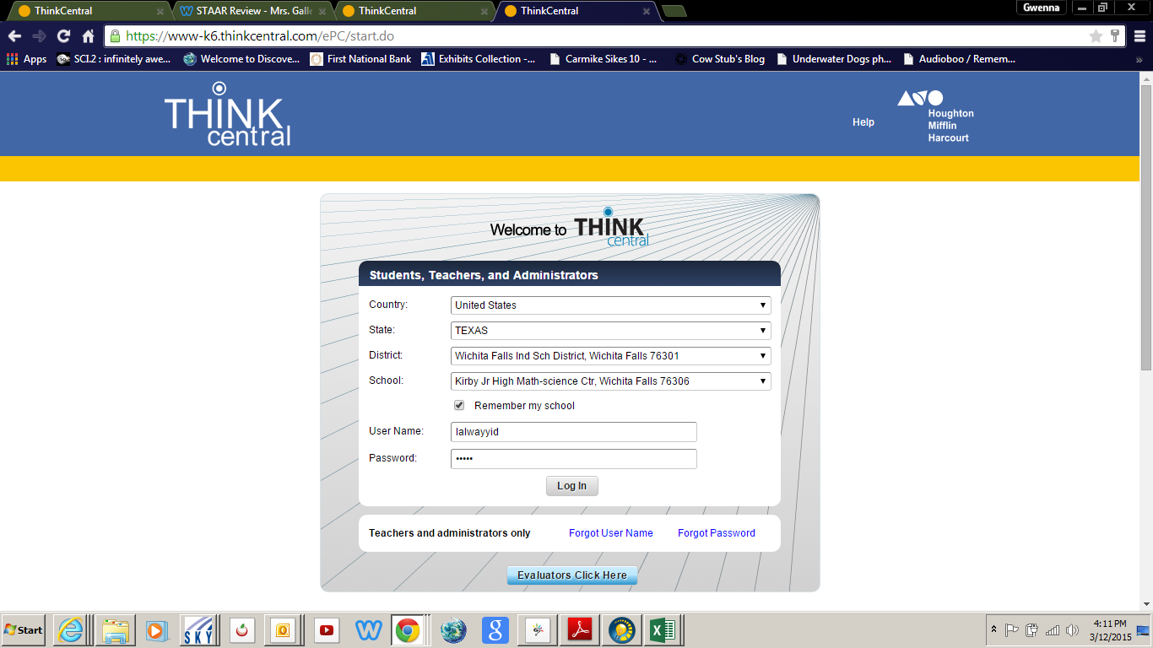

Enter your USER NAME
(first letter of your first name, then your last name)
Example: Joe Smith – jsmith

Enter your PASSWORD (Kirby)

Click “Log In”
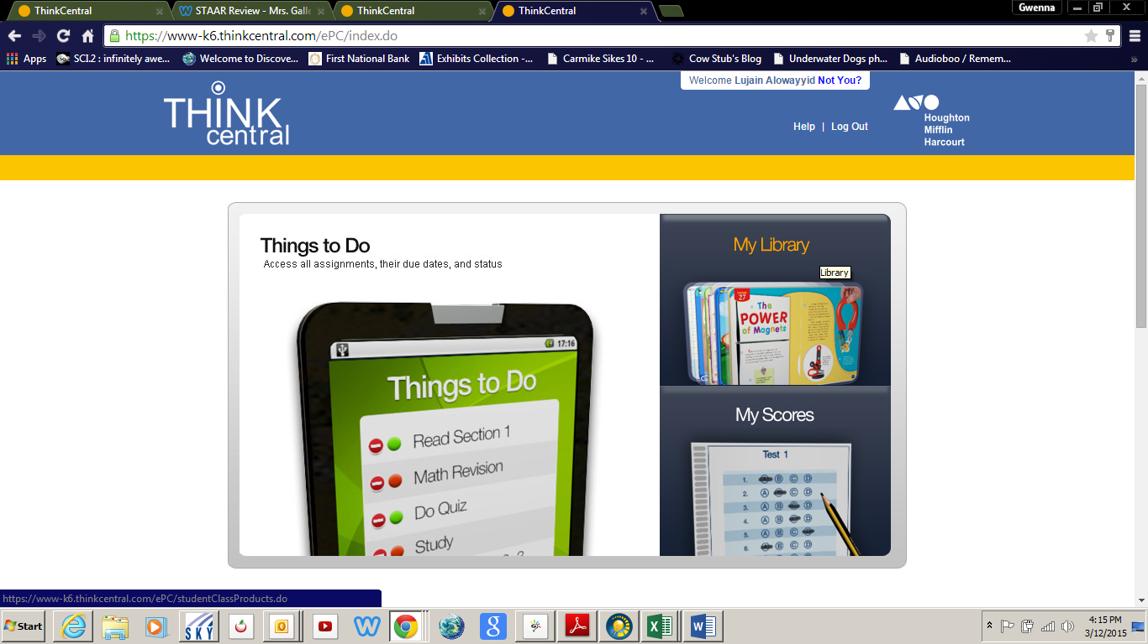

Click on “My Library”

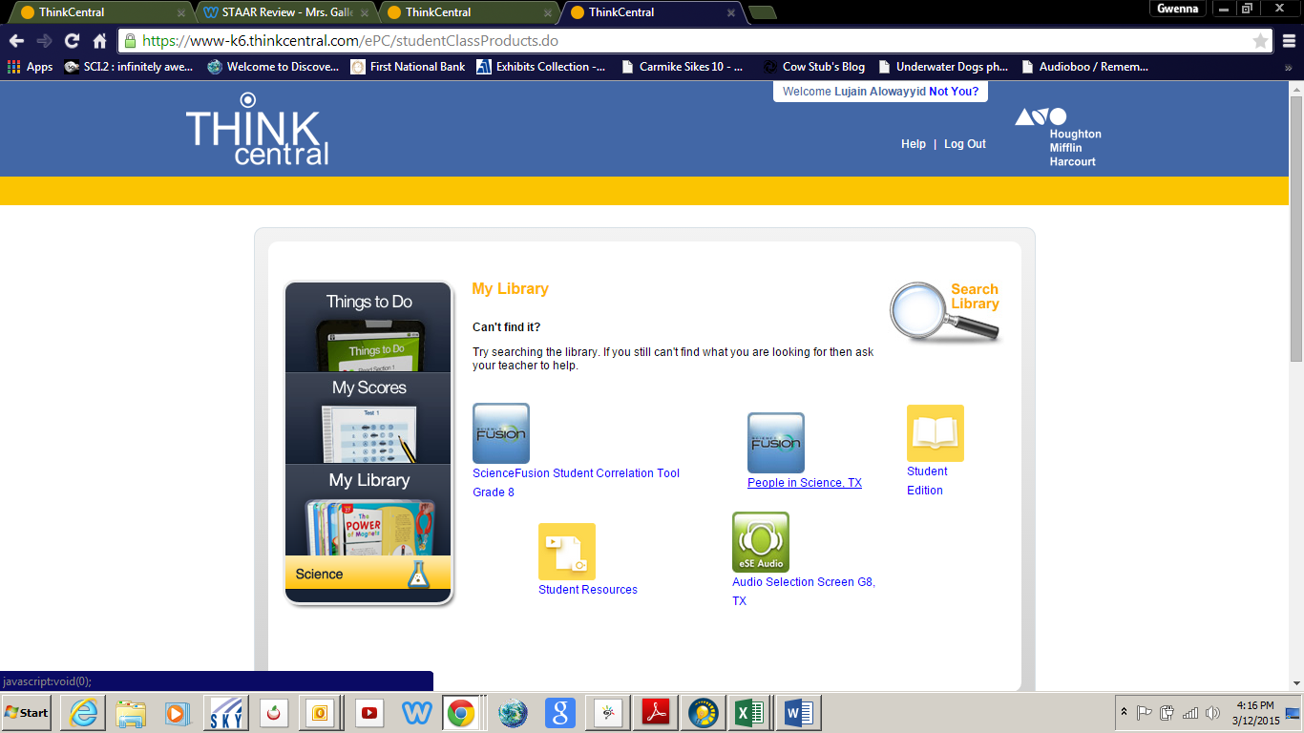

Click on “Student Resources”
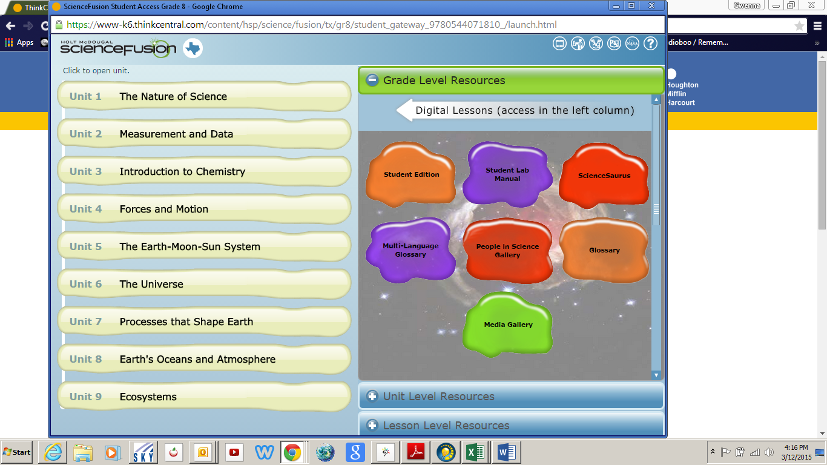

Click on “UNIT 3 – INTRODUCTION TO CHEMISTRY”
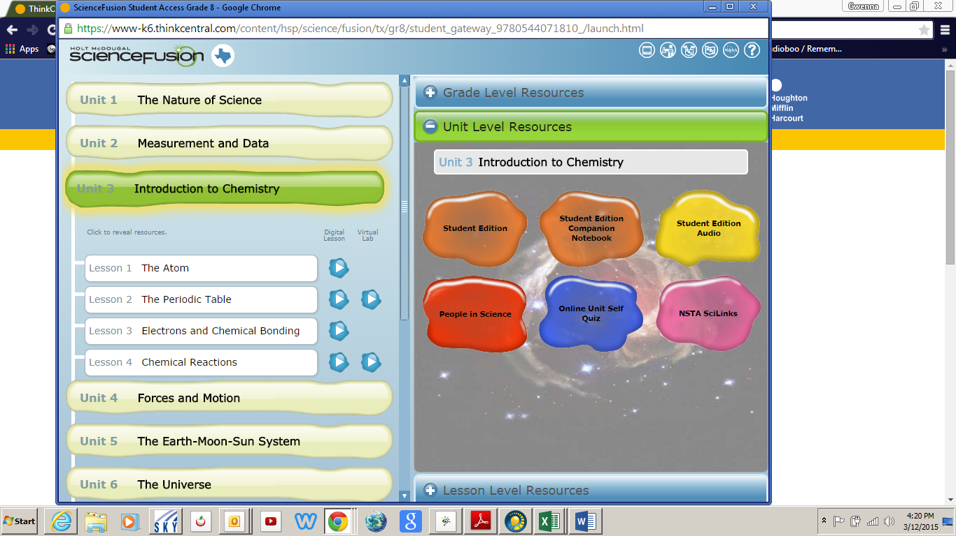
Click on the “DIGITAL LESSON” for Lesson 1 – THE ATOM
(the BLUE ARROW to the right)
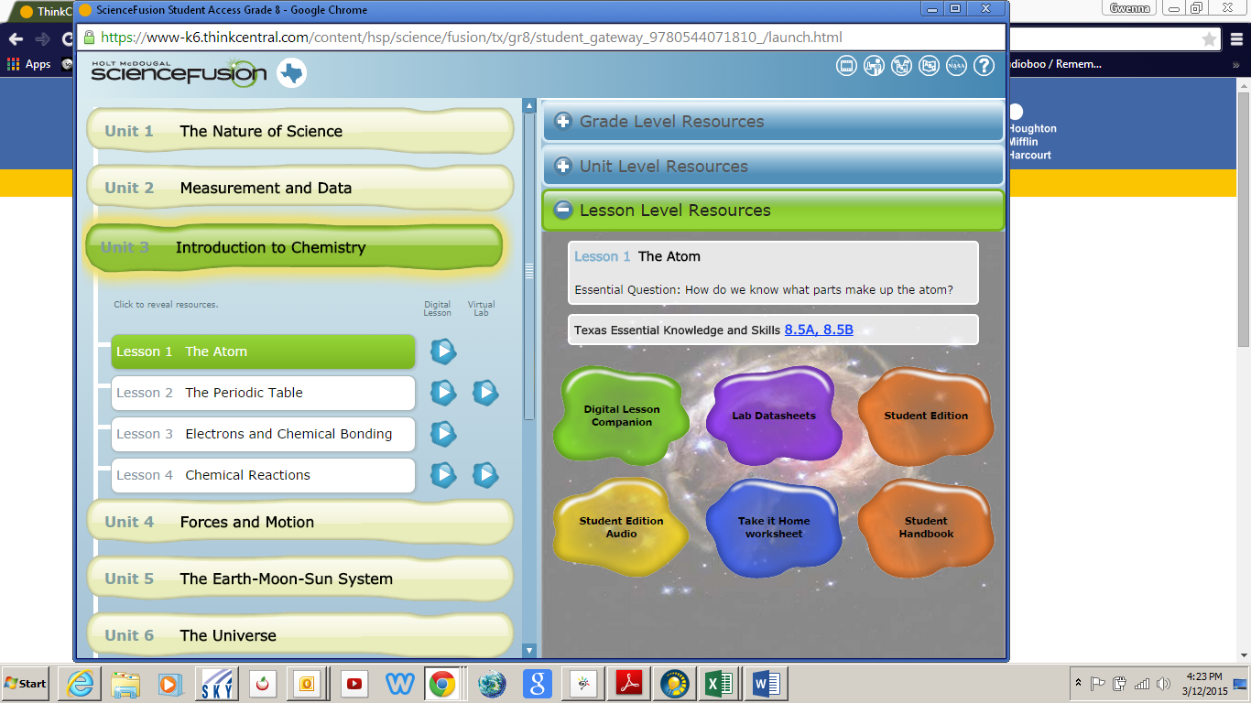

The lesson will be real out loud to you, and there will be places for you to type in your answers.

